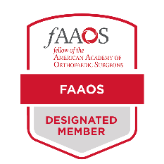
How to Add the FAAOS Digital Badge to Your Outlook Email

Download your FAAOS Digital Badge from the FAAOS Recognition page.

Click File in the upper-left hand corner of your Outlook window
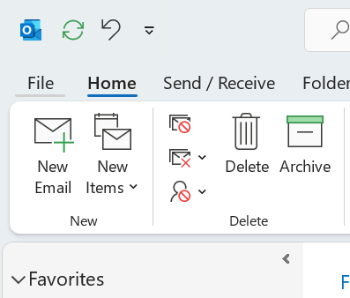

Select Options on the bottom left hand corner
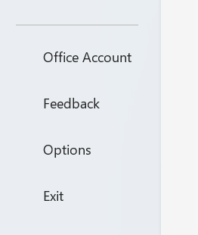
A new window will open. Select Mail on the left hand side and then click on Signature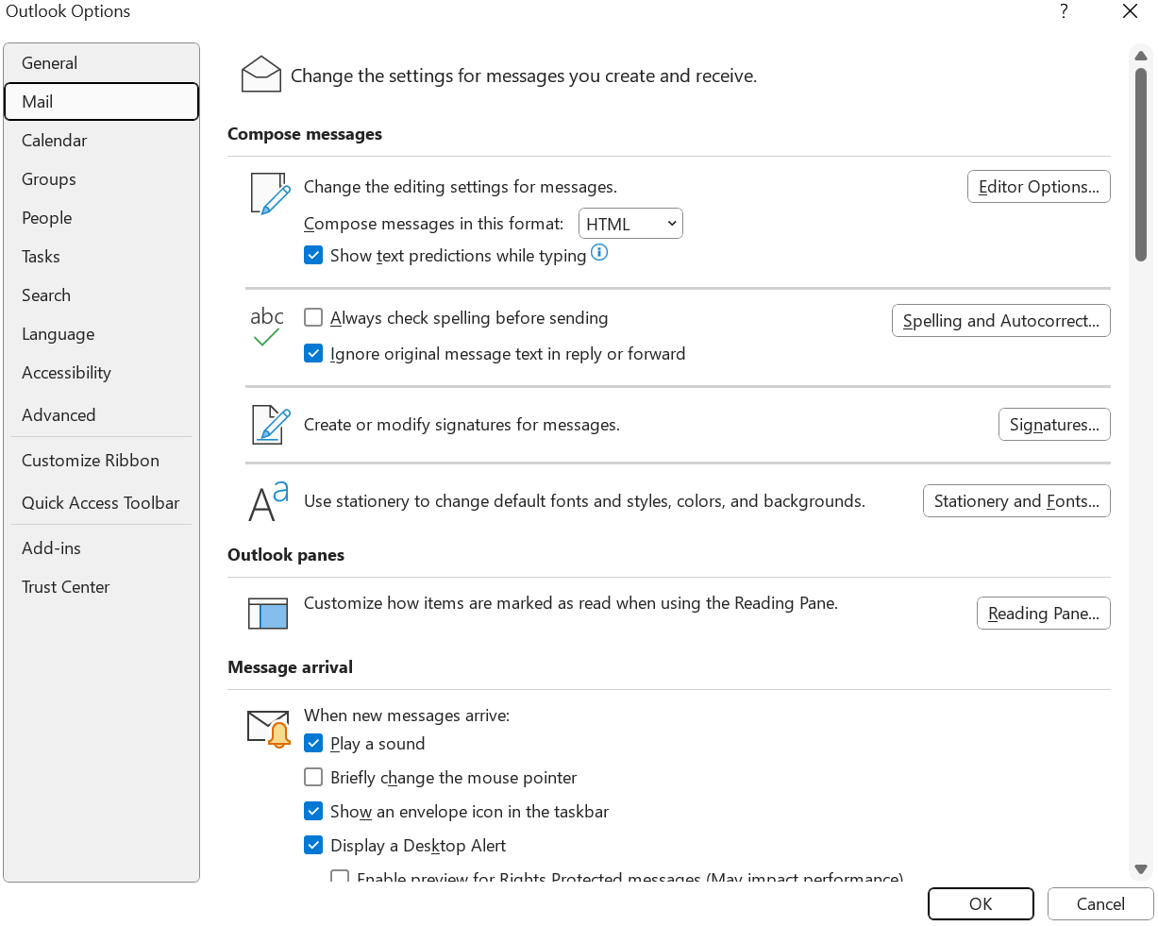

Select the signature you would like to edit or create a new one
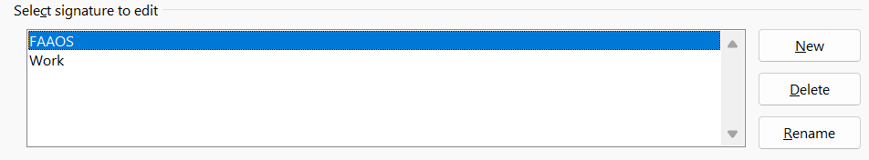

Copy and paste template below to the signature box and add your information

Your Name

Title
Department
Email Address
Phone Number
Website
Office Address

Fill in your information
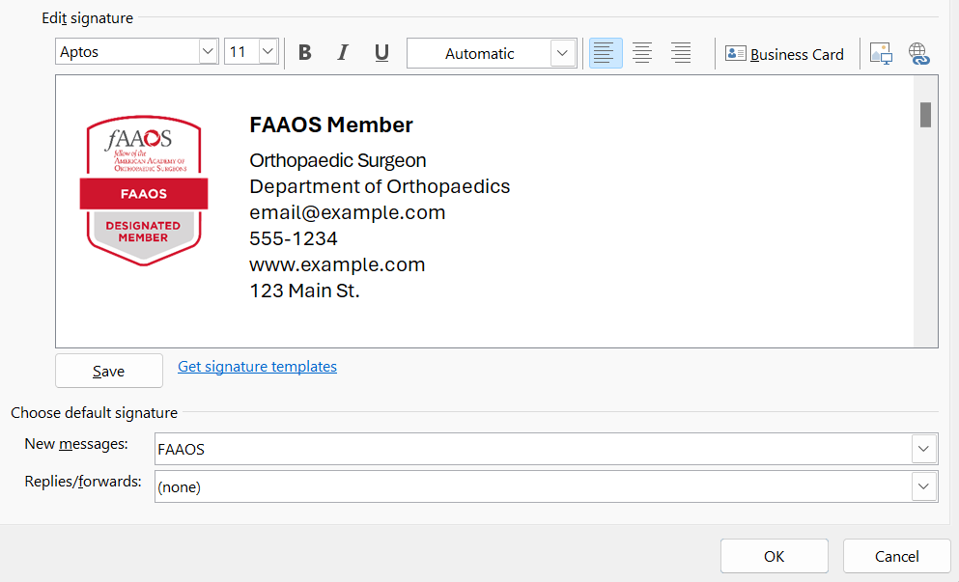

Select Ok to save your changes

