How to Add the FAAOS Digital Badge to Your Gmail

Download your FAAOS Digital Badge from the FAAOS Recognition page.

Click the Gear icon on the upper right-hand corner in your Gmail followed by See all settings
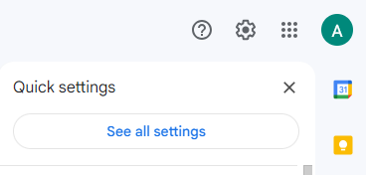

Scroll down to Signature and select Create new

Name your new signature and select Create
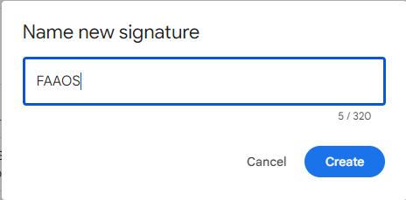

Copy and paste the template below

Your Name

Title
Department
Email Address
Phone Number
Website
Office Address

Add your information
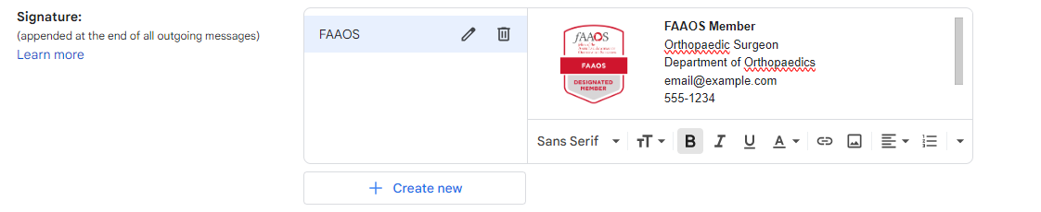
Troubleshooting
- If your FAAOS badge does not appear:
  - Delete badge by clicking on the image and selecting remove
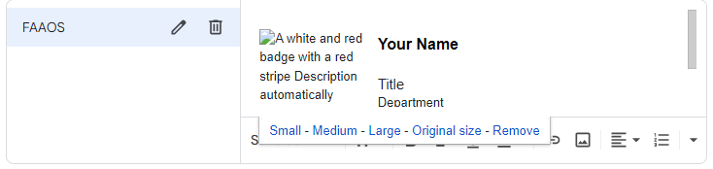
  - To reupload – select insert image icon
  - Upload FAAOS badge
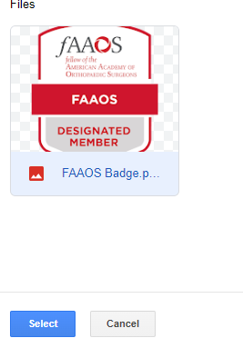

  - Resize by clicking on the image and selecting Small
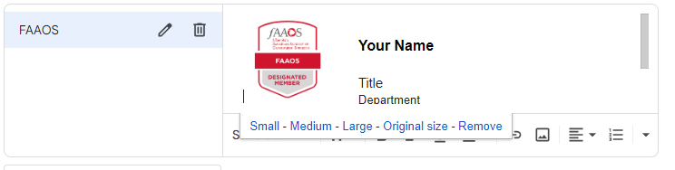

- If the text needs adjusting
  - Select text and click on the downwards arrow on the bottom right corner and select the Remove Formatting tool (first one on the right)
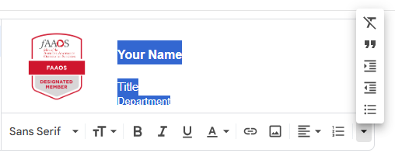
  - Adjust your text as needed

Scroll down to the bottom and select Save Changes

